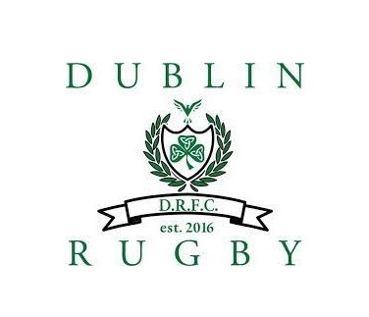
Spring 2021

Register Here →

FREE Pre-Season Camp #1
Saturday 3/13 2pm – 4pm

FREE Pre-Season Camp #2
Saturday 3/20 2pm – 4pm
Pre-Season Parents Meeting: TBD
Practice: Fridays 6pm – 7:30pm | Games: Saturday Afternoons
· 4/9  · 4/16  · 4/23  · 4/30  · 5/7  · 5/14 | · 4/10  · 4/17  · 4/24  · 5/1  · 5/8
*Practices & Games will be at Coffman Park
CAP CITY CONFERENCE CHAMPIONSHIP/EVENT: May 15th
(Location TBD)
Post-Season Event: TBD

Additional Information:
- Game start times will be based on age group (more information to come)
- We plan to have a picture day before one of the practice
- Check out our team supporter apparel:
- Dublin Youth Rugby Team Store
If you have additional questions, please email me: dublinyouth@rugbyohio.com

